Asset Manager Design
This documents the design of the asset manager component.

Overview
Asset Manager is part of the GPCS foundation component set. It manages the accounts and stock information for a GPCS runtime system. The main functions are:

- Validation of transaction data
- Posting of asset information
- Triggered updates of summary asset groups
- Validation of asset transfers between GPCS nodes and users
- Reporting of asset information
- Auditing of asset transactions

Asset manager is fully integrated with the other GPCS runtime components. This includes component manager, transaction manager, error manager.

The asset manager also provides a design-time environment for producing new or updated asset models to be used in a run-time system.

Terminology
The following is a list of the terminology used in this document to describe the Asset Manager. The components are described below.

Term | Meaning
Asset | An item or group of items which is managed by asset manager. These can include values or non-valued items, real or notional items, individual assets or aggregated groups of assets.
Asset Entry | A timed adjustment of an asset. Provides an audit trail for Asset Manager.
Asset Filter | A filter used to select a subset of asset entries for an asset
Asset Model | A system of relationships between asset manager components to provide the business implementation of Asset Manager for a specific GPCS installation.
Asset Owner | An owner of an asset or creator of an asset entry. This can be a person or organisation unit: workstation, department, site, etc.
Asset Quantity | A measurement component which contains a quantity and unit of measurement.
Asset Time Period | A range of time defined by two Time Points
Asset Time Point | A single instance in time. Contains a time value and a system of time measurement (eg, Gregorian, Chinese, etc)
Asset Transaction | A series of asset entries which are applied under transactional control as a single unit.
Asset Trigger | Component used to automatically perform actions (eg, cascaded updates) when an asset is adjusted. Also provides reversability of the action.
Asset Unit | A unit of measurement used by asset quantities. Eg, US Dollars, Sacks, kilograms, etc

Class Diagrams
The following diagrams describe the Asset Manager classes and the relationships between them.

Asset Unit
A support class used for asset quantity. Describes the unir of measurement and holds a universal exchange value for converting between units.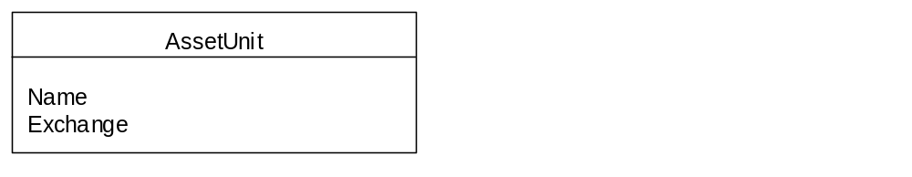

Asset Quantity
A support class used for expressing asset amounts/values. An asset quantity consists of a number and a measurement type (eg, 12 US Dollars, 3 Sacks). It also allows conversion between measurement units .
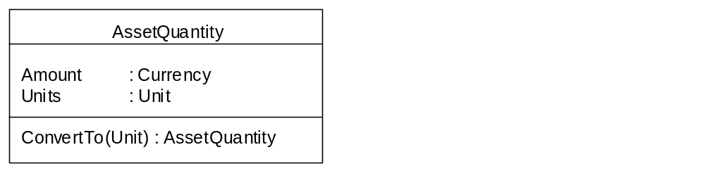

Asset Owner
An owner of an asset or creator of an asset entry. This can be a person or organisation unit: workstation, department, site, etc. The owner can be associated with a site and a parent owner. The site and parent hierarchies allows grouping of owners for reporting by geographic location and organisation structure.

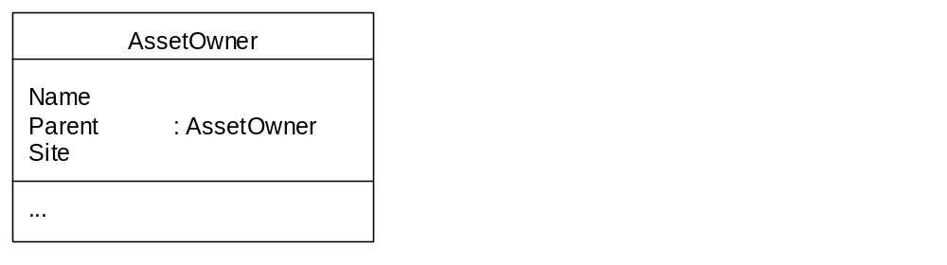

Asset
An item or group of items which is managed by asset manager. These can include values or non-valued items, real or notional items, individual assets or aggregated groups of assets. An asset has a unique code within the system, a short name and a longer description for reporting. The asset balance holds the current value/quantity of the asset. The owner describes the nominal owner of the asset: this may be an individual or organisation unit (office, region, etc).

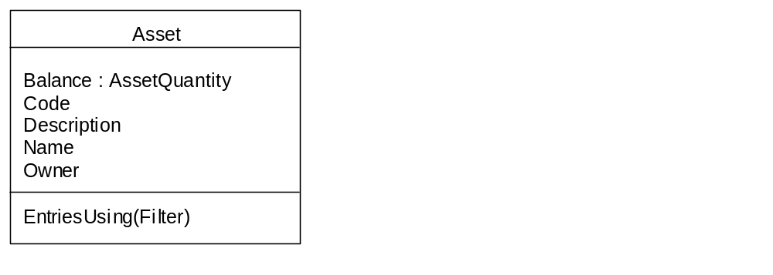

Asset TimePoint
A Time point defines a specific instant in date and time. It also defines the measurement system used.

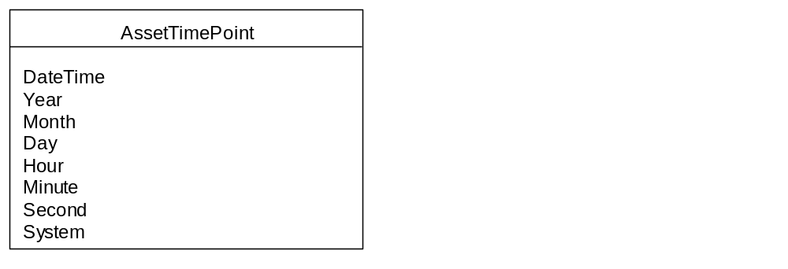

Asset TimeRange
A Time range defines a range of time between two time points.

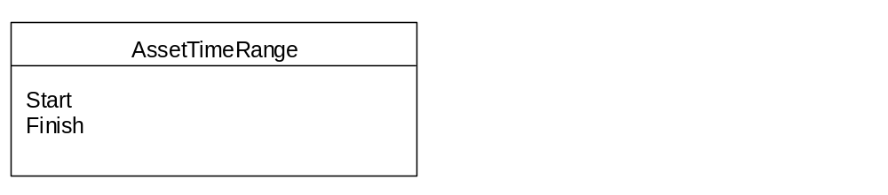

AssetEntry
A timed adjustment of an asset. The asset entries record a history of how the asset has changed over time. The asset entry has an amount to adjust the asset balance. It also contains two times: one to record when the entry is charged and another to record the booked date. The Creator holds the initiator of the entry: typically this will be a person or an automatic process such as a stock reorder.

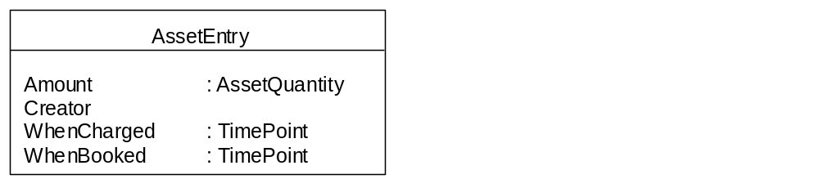

Asset and AssetEntry
An asset’s balance (current value) is a result of all asset entries that have been applied to the asset. The asset entry amount adjusts the asset balance directly. Initially an asset will have no associated entries. As asset entries are added the asset balance reflects the changes. The asset entries provides an audit history for the asset.

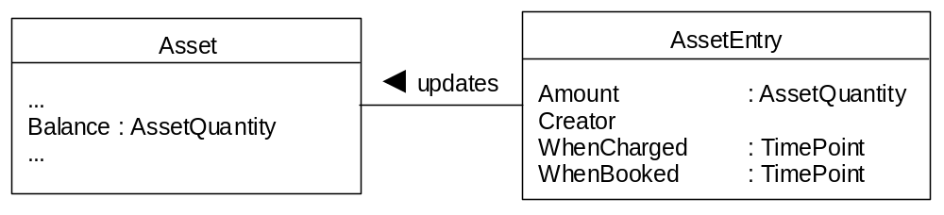

AssetTransaction
An asset transaction ensures that all asset entries in the transaction will be applied together under transaction control. Optionally a transaction can ensure that the asset entries total zero (for conservation of asset balances).
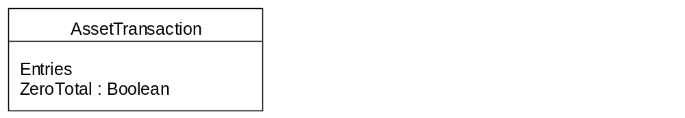

Asset Transaction and Asset Entry
An asset transaction contains at least two asset entries.

Asset Triggers
An asset trigger is used to connect a child asset to a parent asset. The asset trigger will use the child asset entries to calculate an update for the parent asset. The calculation may a simple multiplier, eg, ChildAssetEntry*1 for totalling, ChildAssetEntry*CurrentTaxRate for a tax liability asset. Alternatively the calculation could involve further processing before returning an adjustment value for the parent asset.

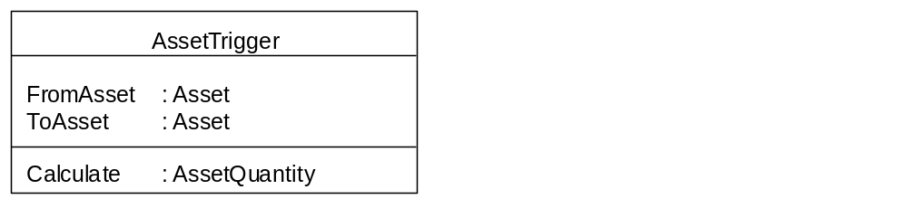

Asset Triggers and Assets
Assets can be placed in a hierarchy. This groups child assets together under a parent asset. The parent asset’s balance is determined by the children assets’ balances.

The asset trigger must be capable of reversing an asset entry. When a contra asset entry is made (ie, –ve for a +ve entry, +ve for a –ve entry) the asset trigger calculation must return an asset quantity that will adjust the asset balance to the same value before the first entry was made.
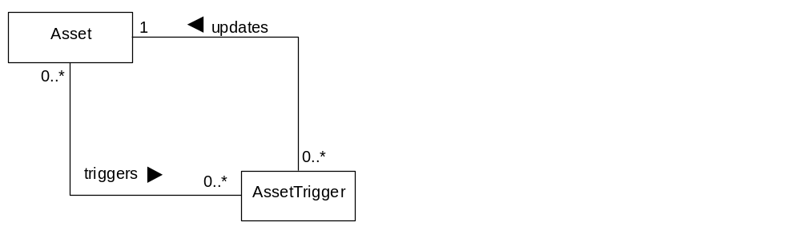

Asset Model
A specific hierarchy of assets connected by asset triggers forms an asset model. The model determines how the asset manager propagates asset entries through the system.
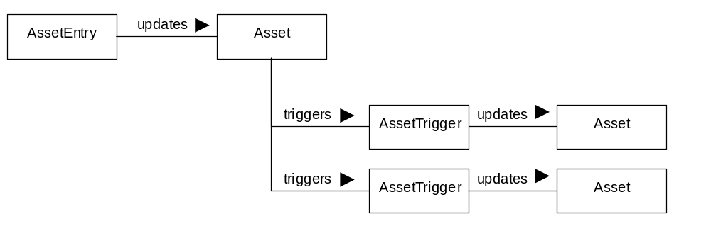

Asset Filters
Asset filters are used to select a subset of entries for an asset. A filter encapsulates a query which is used to select the entries. Because some of the filtering requirements are common for all filters these are implemented : TimePeriod, Creator, Charged, Booked. The creator can be a defined group of creators, eg, all clerks, telecom clerks.

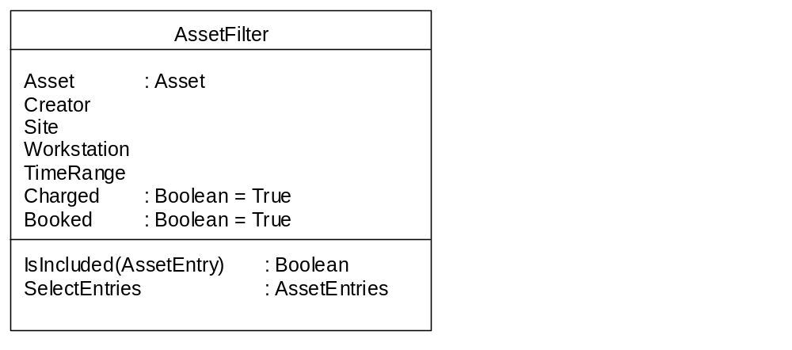

Asset Filters and Assets
Asset filters are used with a specific asset to select the relevant entries from the asset entries.



